Ranking Page Add new standing per month  
  
Page > [www.funfunspell.com](http://www.funfunspell.com/) > click “Ranking” at the left bar  
  
Existing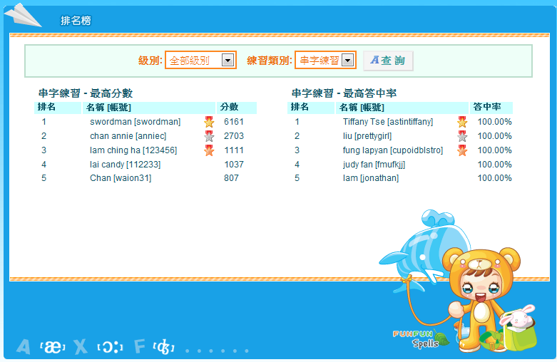  
  
To:  
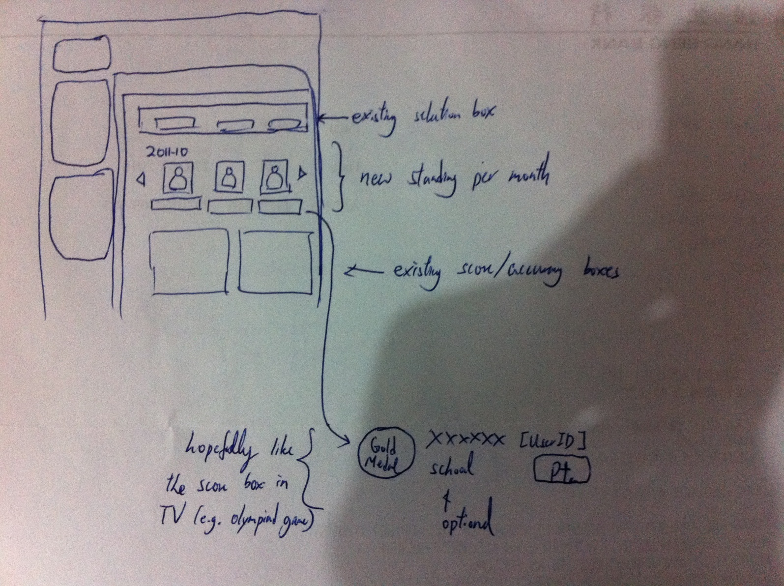

**Graphics needed:**

a) Three medals:

e.g. 

b) Buddy, used for client do not have photo

e.g. 

c) Optional, may be done by HTML

A Box for holding the “Point/ Score”

Other Changes:  
1) Rest URL  
2) Full Ajax query  
3) Fix level box